## LUMS Board (Australian Version Only)

This tool helps you create a Lanes Use Management System (LUMS) across a roadway on your plan. There are 10 different LUMS styles available for your plan.

| Patterns |  |  |  |
| --- | --- | --- | --- |
| 100_LUMS_table | 100 km/h | 80_LUMS_table | 80 km/h |
| 60_LUMS_table | 60 km/h | 40_LUMS_table | 40 km/h |
| Merge_left_LUMS_table | Merge left | Merge_right_LUMS_table | Merge right |
| Exit_left_LUMS_table | Exit left | Exit_right_LUMS_table | Exit right |
| Cross_LUMS_table | Cross | Blank_LUMS_table | Blank |

## Creating an LUMS Board

* Select the **LUMS Board** tool in the Devices tab in the Tools Palette.
* Click once to place an LUMS Board the first lane, continue this for each lane.
* Once all of your LUMS Boards are set, you can select each one and change its style in the Properties Palette under the **Style** tab and the **Icon** drop down menu.
* Right click to finish
* 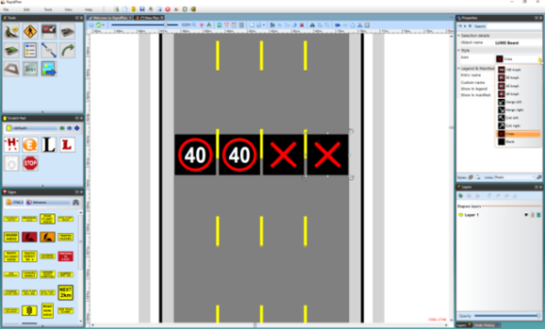
* LUMS\_Board\_Properties\_Palette